Query language
To form and execute queries to database tables, the special Query object is used in the 1C platform. A query is convenient to use when there is a need to get a complex selection of data grouped or/and sorted, as needed. One of classic examples of its use is a summary of the register of record's state at a certain point in time. Besides, the query feature allows you to easily receive information in different time sections.
To execute a query, you must compose the query text. 1C uses an SQL-like query language, so the syntax is as close as possible to the SQL query language; during query execution, the platform automatically converts it into a query text in accordance with the SQL server used.
Data sources for queries can be database tables, value tables passed into query parameters, as well as temporary tables. Database tables are divided into two main classes: real and virtual.
Real tables are stored in a database, that is, they are interpreted from a real database table. In case of a real table, there may be present the calculable fields whose values are calculated as function of several real fields.
Virtual tables are not stored in database. When accessing information from virtual tables, the system automatically collects information from real database tables to execute a query. A virtual table can be parameterized, that is, the actual content of a virtual table can be determined by the values of parameters the actual values of which are specified in the query text. For each virtual table, a name is defined that is used in queries to identify a table. We will study virtual tables in detail in lessons on information and accumulation registers.
Let's look at an example: we need to get the amounts of all valid contracts by counterparties. A contract is considered valid if its start date is less or equal than the start of the current day and its end date is greater or equal than the start of the current day. The result must be sorted in descending order of the amount.
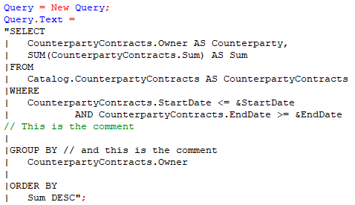
Let's analyze the above code: first we create a new object of the Query type, then we set the text for this Query object using the Text property. The query text must always begin with the required SELECT keyword. This is the only required keyword, the rest of the keywords are optional, which means the query can be executed without them.
Next, selection fields are specified. The selection fields follow one another, separated by commas. It is possible to select all fields from the table; to do this, instead of specifying the fields, just write the operator *:
"SELECT
| *
|FROM
…
If you need to specify an alias for a field, that is, a name by which it can be accessed further, this can be done using the AS keyword. As selection fields you can also specify expressions that perform certain operations on the fields, for example, when selecting the Price and Quantity fields, you can create another field in which you can specify the operation of multiplying price and quantity and placing the result in a field with the alias Amount:
"SELECT
| Products.Product AS Product,
| Products.Quantity AS Quantity,
| Products.Price,
| Products.Quantity * Products.Price AS Amount
If you do not specify an alias for such expressions, the platform will automatically assign one; in the example above, the alias will be Field1.
After the description of the selection fields, there is the FROM keyword to specify one or more data sources after it. In our example data is selected from one table - the CounterpartyContracts catalog. For data sources, you can also specify aliases after the AS keyword.
The WHERE section is used to specify the conditions to be applied to the query. Conditions can use not only the fields selected by the query, but also other fields of the data sources. The condition is always a logical expression, which means that the result of the calculation must be True or False. In conditions, you can use operations on selection fields, predefined values, values of primitive types, values passed to query parameters, as well as on virtual fields, which we will talk about later.
On the next line after the condition in the example there is a comment line. The comment in the query does not affect anything and can be written in two ways: 1) with a break in the query text, i.e. on a new line inside the line with the query text; 2) without a line break - right inside the query text after two symbols “/” (the usual rule for writing a comment in 1C).
To group the result by some fields, use the GROUP BY section, which lists the grouping fields, i.e. records with the same value in the fields listed in this section will be “collapsed” into one record, and aggregate functions can be performed on the remaining fields, such as summing (SUM), counting the number of different values (COUNT(DISTINCT <field>)), counting the number of values (COUNT), maximum value (MAX), minimum value (MIN), average value (AVG). In our example, I use the SUM function to sum up the Sum field, as a result of which the sums of all contracts of each counterparty are collapsed into one value, for example records
Owner | Sum
The best company | 50000
The best company | 70000
will be converted into one record
The best company | 120000
To order the query, use the ORDER BY section, which specifies the fields or expressions to be sorted, as well as the sort order (ascending or descending). To sort in descending order, you need to specify the DESC keyword after the sort field; if it is not specified, then the sort order is in ascending order. A field that appears in the ordering conditions does not necessarily have to be included in the query result.
For hierarchical objects (such as a catalog), sorting by hierarchy is available. Hierarchical sorting can also be in ascending or descending order and works as follows: first, the sorting expression is applied to the parents of the objects selected by the query, starting from the top level, then the next level of each parent is sorted, and so on until the last level of the hierarchy in relation to the objects included in the result request. To sort by hierarchy, use the HIERARCHY keyword after the sort field. If it is necessary to sort by hierarchy in descending order, then the keywords are written one after another, but HIERARCHY comes first, i.e. <field name> HIERARCHY DESC.
Let's look at the result of regular sorting and sorting by hierarchy using an example. There is a hierarchical Products catalog of the following content:
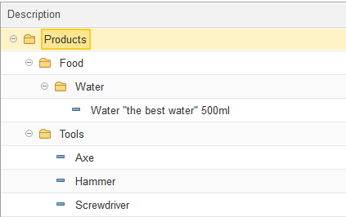
Results of regular sorting and sorting by hierarchy by catalog description:
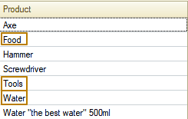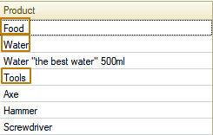
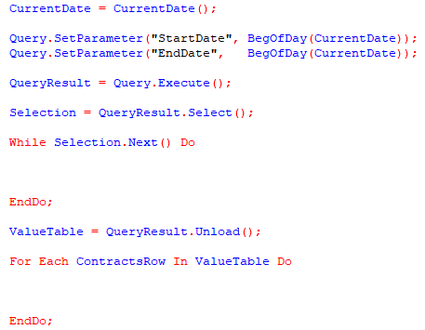
In order to execute our query, we need to set the value of the parameters that we specified in it - &StartDate and &EndDate. The request has the SetParameter() method, which allows you to set the value of the parameter; the first argument of the method is the name of the parameter, the second is the value of the parameter. In the example above, we got the current date into the CurrentDate variable at first, and then set the parameters to bring the current date to the beginning of the day using the BegOfDay() method.
Next, we can execute the query; for this we use the Execute() method. This is a function that returns an object with QueryResult type, we place the returned value in the QueryResult variable. Then we can obtain selected data from this object in two ways: select records line by line using the Select() method (the result will be an object of the Selection type) and select all records at once into a table using the Unload() method (the result will be an object of the ValueTable type). The second method of uploading to a Value table is usually used when we need all the data at once to perform some subsequent actions. However, it should be understood that the Value table is stored in RAM, so the more data it contains (rows, columns and the size of the data itself), the more memory will be allocated. A Selection has the advantage of storing data from one record at a time, which means it does not take up much space. Each option has pros and cons; accordingly, you should approach the choice of option for working with the query result based on the tasks that you face.
Now that we have become a little familiar with the theory about queries, it’s time to meet with a tool for generating query text in interface mode; for this purpose there is a “query wizard” tool in 1C. You can open the query wizard from the module’s context menu or from the “Text” section of the main menu. There are 2 options for the query wizard: build only the query text and build a query with result processing
Call for a query wizard from the context menu:
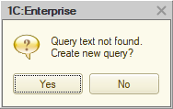
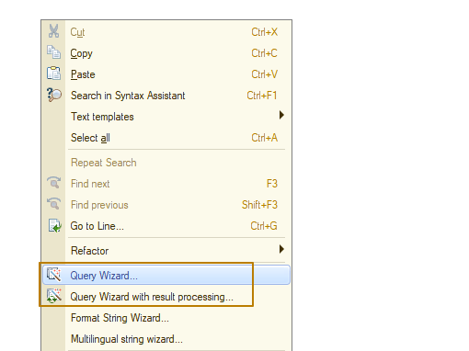
Now let’s build a simple query to select all structural units and sort them by descending description with hierarchy. If you open the query wizard outside of a code block with the result of a previous query built using the wizard, the platform will inform you that the query text was not found, whether you are sure you want to continue. Let’s agree by clicking “Yes”:
The query wizard window has opened:
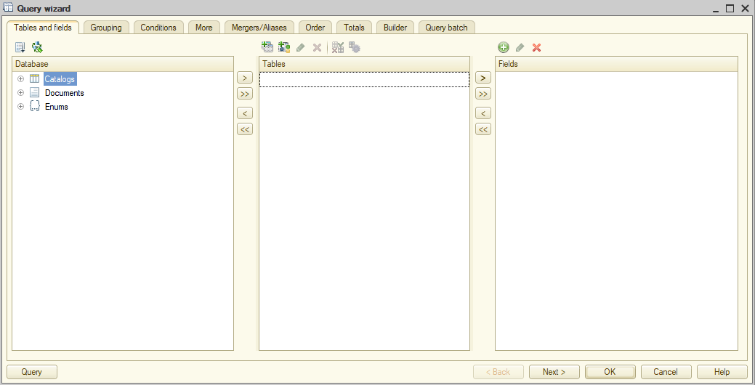
This is what the query wizard with result processing window looks like, it differs from the previous one only in that in the first place it has an additional tab - result processing:
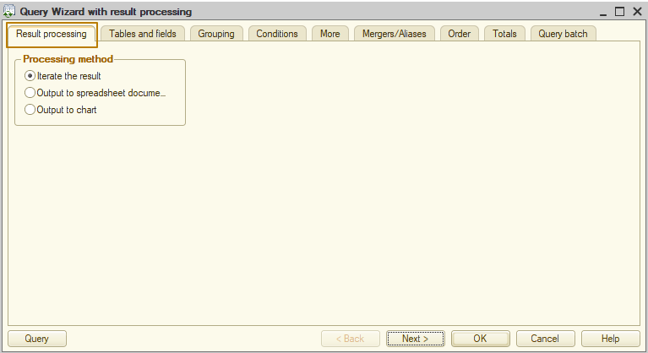
The “Tables and fields” tab allows us to manage data sources and selection fields. There are three lists here, the first of which contains all the infobase tables, the second contains the selected tables, and the third contains the selection fields.
I will select the “Structural units” catalog as the data source, and I will select one Ref field as the selection field:
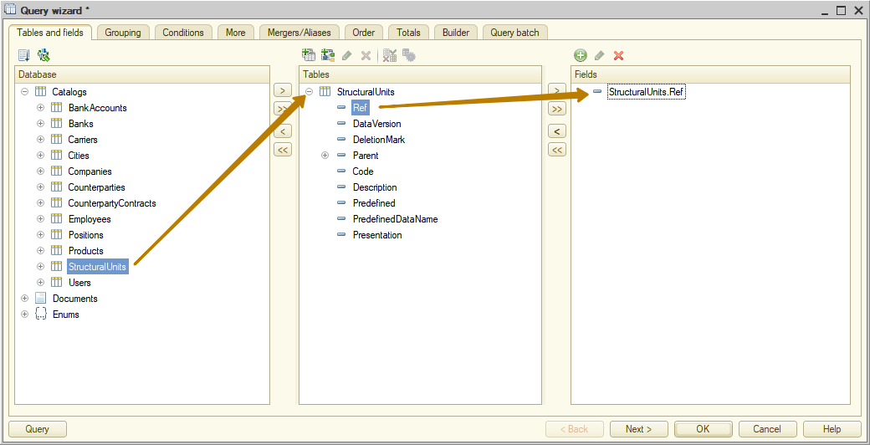
Now, to change the sort order, you need to go to the Order tab. In the left list, only the fields selected by the query are initially visible. If you need to sort by other fields of the data sources, you should expand the "All fields" node, then expand the desired table and select the sorting field. In my case this is Description field. You can select a sort field by double-clicking, dragging, or pressing the arrow button. In the Sort column you can select the sort order, so I choose “Hierarchy, descending”. 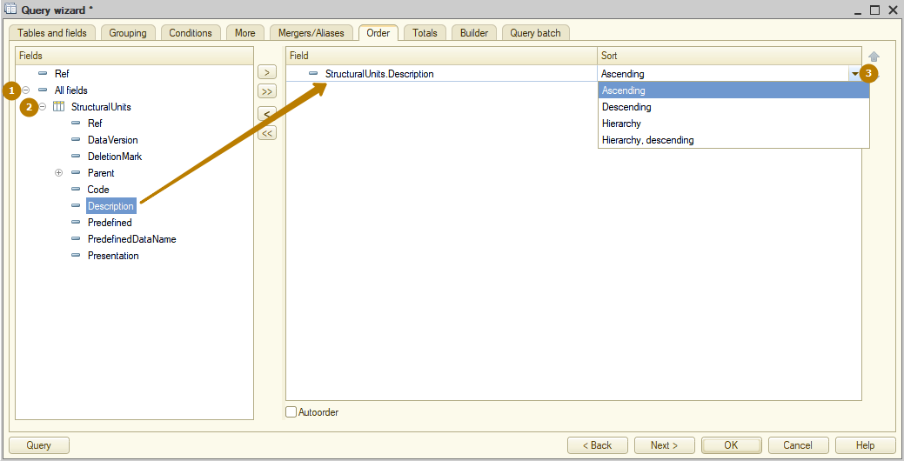
Let's save this request by clicking "OK" and look at the result. This is how it looks in query wizard mode:
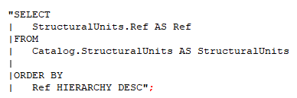
This is how it looks like in the “query wizard with result processing” mode:
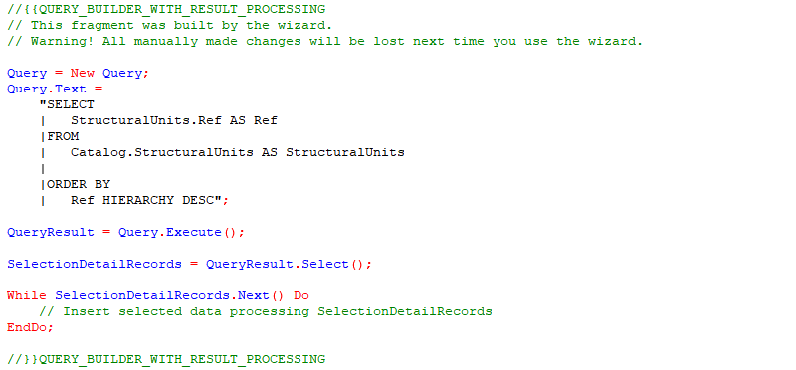
You can see that in the second case, the platform created a Query object for us, set the query text for it, then there is a code for executing the query, creating selection from the query result and iteration of this selection. Those, all that remains is to set the query parameters, if any, since the code for setting the query parameters is not created from the query wizard, and also to add your own algorithm for processing the selected data. You should understand that if you change some code, for example the result processing code, then the next time you use the query wizard with result processing, your code will be replaced with the standard one. Therefore, it is recommended to use the query wizard with result processing only before making any changes to the code other than changing the query text. After making changes to the surrounding code, it is recommended to change only the query text using the query wizard.
We have already covered some query sections and keywords. Let's look at a few more query sections and keywords.
SELECT [ALLOWED] [DISTINCT] [TOP <Count>]
<Selection field list>
[FROM <Source list>]
[WHERE <Filter condition>]
[GROUP BY <Grouping fields>]
[HAVING <Filter condition>]
[ORDER BY <Sorting fields>]
The ALLOWED keyword means that a query will select only those entries to which the current user has rights. If this word is not specified, the query will be completed with an error when it selects records to which the user does not have rights (We will talk about roles, rights and access restrictions later, for now it is enough to remember what this keyword is used for). This keyword can be specified only in the top-level SELECT clause and applies to the entire query including nested queries. Note that the ALLOWED keyword affects the operation only if tables have data access restrictions. Access rights to the table are not considered when using the ALLOWED keyword. For example, if a table does not have the READ right, a query using such table will be executed with an error regardless of whether the ALLOWED keyword is used in the query.
Use the DISTINCT keyword to specify that duplicate strings cannot be included in the result. For example, we want to select all products that appear in the SalesInvoice document; with a normal selection, each product will appear in the query result as many times as it appears in the documents. To ensure that it occurs only once, you can use the DISTINCT keyword.
Tip: you should not use this keyword unless necessary, for example when you know for sure that there are no duplicate records in the query result, as this creates additional load on the computer and this can significantly affect performance on large amount of data.
The TOP <Count> construct sets a limit on the number of strings in a query result. The very first (according to the rules for ordering query results) strings will be selected. The number of results is specified as an integer. In the query language, you can order in nested queries if a nested query contains the TOP construct.
The HAVING <Filter condition> clause allows setting conditions for aggregate function values. In other query language structures, for example, in the WHERE clause, you cannot specify aggregate functions as conditions.
Let's look at an example to make it clearer. Imagine we received the task of modifying the query from the beginning of this lesson so that it would display only counterparties whose total amount of all contracts exceeds 50,000.
Let's imagine that the counterparty "The best company" has 2 contracts, one for the amount of 30,000, the other for 40,000. If we write a condition for the contract sum in the WHERE section, it will apply to each individual contract, this option will not suit us, because both contracts do not satisfy the condition and as a result the selection result will be incorrect. We need to add up the sums of all contracts in the request using the aggregate function and apply selection to the resulting value. This is what the HAVING section is used for.
First, the records in the request will be grouped (GROUP section), and then the condition will be applied, as a result, the amount of contracts of the counterparty “The best company” will be 70,000, which is more than 50,000, so the record for this counterparty will be included in the final result.

This is what such a condition looks like in the query console:
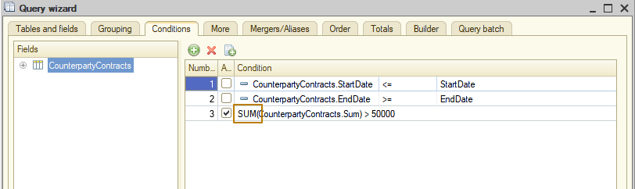
And this is what the query text looks like:
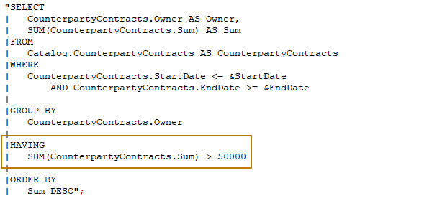
A selection field list can refer to a nested table of a query data source. In this case, a query result field will be of the QueryResult type. It will contain a nested query result generated based on the nested table, which is a source. When you unload a query result to a value table, those nested query results will also be unloaded to the value tables. The result will be a value table in one or more columns of which there will be nested value tables.
By default, a nested result includes all fields of a nested table, which is a data source. You can explicitly define a group of fields that must be contained in a nested query result. For example, we want to select SalesInvoice documents for a certain period, and the records should contain the main information and data from the Products and Services tabular sections. To do this, we select attributes and table sections from the data source, indicating which attributes of the table parts should be included in the query result.

This is what the query text looks like:
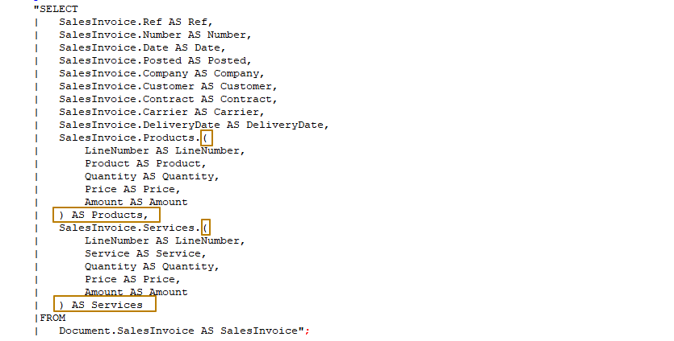
The attributes that should be selected from the tabular section of the document are indicated in brackets. You can specify the * symbol to select all possible fields.
This is what a selection record from a query result looks like:
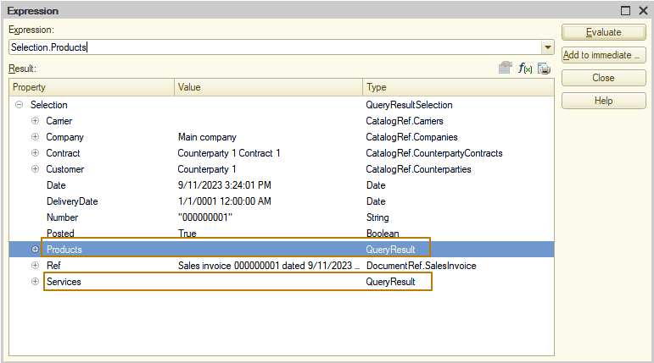 In this case, the selection record contains the Products and Services fields with the QueryResult type, to obtain data from which you can execute the Select() method to get Selection object or the Unload() method for unloading data into the value table.

And this is what the value table unloaded from the query result looks like:
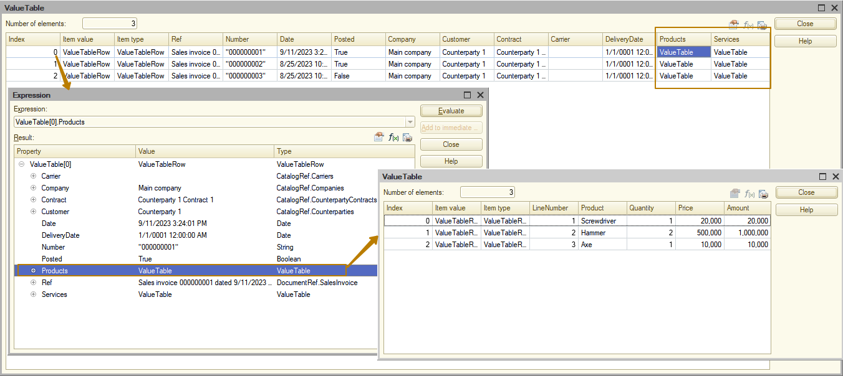
Joins
In case of selecting data from several data sources, for example from 2, for each record from the first source, all records from the second source are selected. So, all possible combinations of all records from all specified sources are generated in the query result. Let's look at an example. I will select the Products catalog reference and the SalesInvoice document reference from Products tabular section of the document:
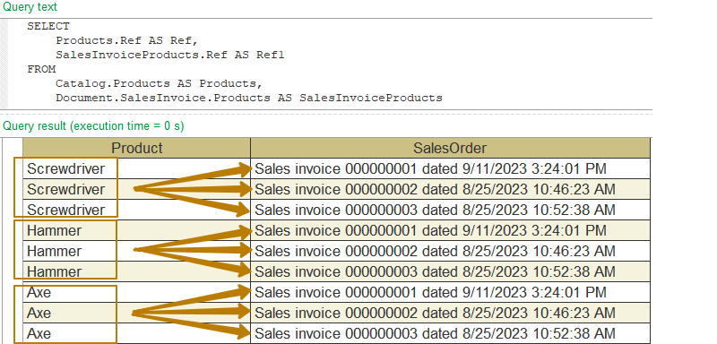
You can see that in the resulting table there are 3 different references to the PersonnelChange document and 3 different references to the SalesInvoice document, with a total of 9 rows - these are all possible combinations of this data.
Usually, combinations of records from different source tables must be limited by some conditions. In the query language, you can describe such source join. To do it, specify the sources and determine conditions for including combinations of records from these sources in the query result.
Joins can be of several types. There are 4 types of connections:
- [INNER] JOIN <Source description> BY <Filter condition>
- LEFT JOIN <Source description> BY <Filter condition>
- RIGHT JOIN <Source description> BY <Filter condition>
- FULL JOIN <Source description> BY <Filter condition>
although in 1C we use only three, because a RIGHT join can be expressed through the left join. This is exactly what the query wizard does when it's finished working with it - it changes the text of the query with a right join so that the join becomes a left join.
In general, the list of joins can contain and describe not only a single join (of two sources) but also multiple joins of several sources at once.
Source description contains a source table description.
A filter condition contains conditions that describe how to join data from source tables, that is, query sources, in the selection. Do not use subqueries to describe filter conditions. This can significantly slow down a query and in some cases result in its failure in some DBMSs.
The LEFT, RIGHT, and FULL keywords specify join details. The INNER keyword can be omitted. It only increases the query text readability, so I prefer to use it.
Sources to join are not equivalent to each other. In some cases, the result depends on which table is listed as the first one, that is, before the JOIN keyword (to the left), and which table is specified as the second one (to the right).
For example, if we want the query to select only the Products and SalesInvoice documents that contain these products, we need to join these tables and specify a filter condition by product reference.
Inner join
The INNER join means that a query result must include only combinations of records that meet the specified condition from both source tables, which are data sources. The rest of records do not make to the result.
Let's see how we can add a table join to the query text:
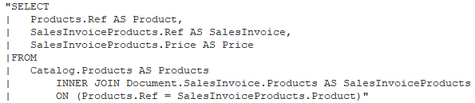
You can see that I connected the tables using a ref to the Products catalog.
In the query wizard connections are configured on the Links tab. The All flag means that all records should be selected from the table. If this flag is disabled, only records that match the connection conditions will be selected.
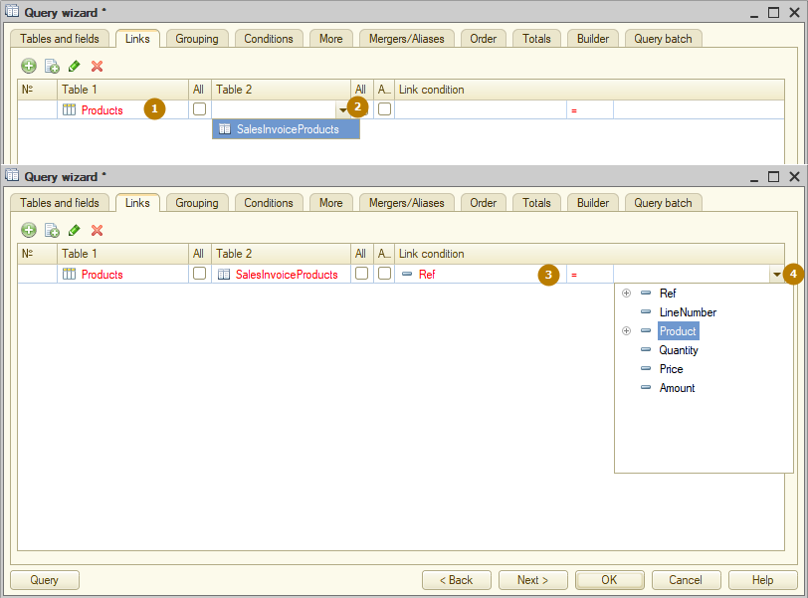
The result of the query:
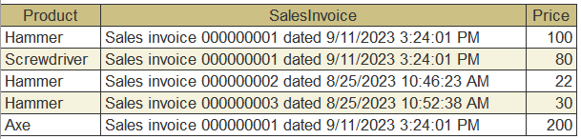
Left join
The LEFT join works differently - the result includes all records from the first source, and records from the second source are included if the selection conditions are met.
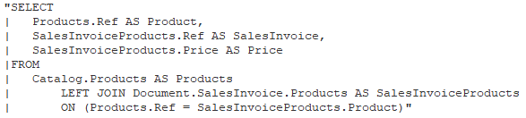
Moreover, if the query selects fields from the second source, but there are no suitable records in it for some records of the first source, then the values of the selected fields will be NULL:
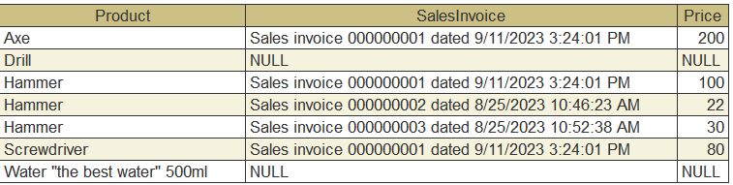
This example selects all records from the Products catalog table (this is the first data source), then selects records from the SalesInvoice document table where product = ref of the Product from the first source (this is the second data source). No records were found for two products in the document table, so in the records with these products, the fields selected from the second source have the value NULL.
Full join
The FULL outer join means that the result of query must include combinations of records from both source tables that meet the specified condition. In addition, the query result must also include those records from both sources for which no matches were found.
So, the result of query will include all records from both sources. They will be connected to each other when the specified condition is met. Query result strings for which no matching records from any source are found will contain NULL in the fields generated based on the records from this source.
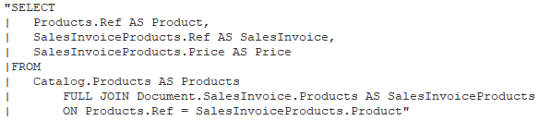
The result of the query:
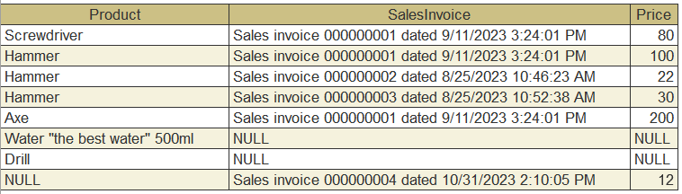

Nested tables and queries
The list of sources may include nested tables - tabular sections of catalogs and documents. In the previous examples I selected data from the Products tabular section of the SalesInvoice document. This is quite necessary during development, so let’s look a little at the capabilities of the query language when working with tabular sections.
In tabular section of the object there is a Ref field, which stores a link to the owner of the tabular section (catalog, document). Using this field, you can connect tabular sections to each other or connect a tabular section and the owner object.
For example, I want to get data about the Total sum of goods of each sales document.
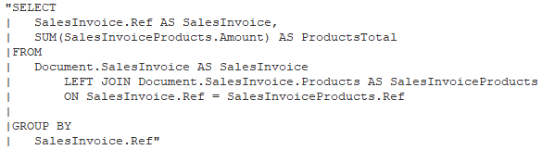
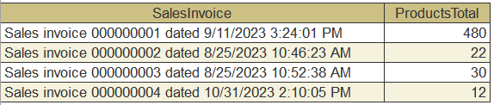
In the query source list a nested query can be used as a source table. In this case, a source description contains a nested query description. A description of a nested query is made the same way as of a standard one. All fields described in the selection field list of a nested query can be fields of such query.
In general, using a nested query as a data source is no different from using an infobase table. However, joining tables with nested queries can have a negative impact on query performance, since the built-in DBMS optimizer may build the query plan incorrectly, and then the query may take several times longer to complete than it otherwise would. Therefore, it is better to use nested queries only if there are no joins with other tables or it is known for sure that all the tables being joined have very few records.
Let's consider a more complex task - we need to select the sum of all products and the sum of all services of a certain SalesInvoice document. Moreover, if the document does not have rows in the products (or services) tabular section, then the query result record should still contain a record for the document, just the sum of the products (or services) will not be empty.

Let's take a document with 3 products and 1 service. The sum of all products is 480, the sum of services is 1000.
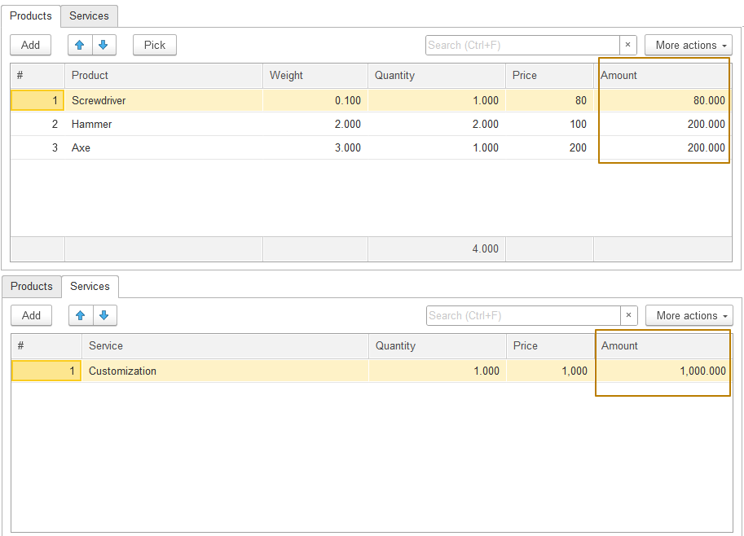
If we write a connection between a document table and its tabular parts, the result will be incorrect, because we use one connection field - Ref. Accordingly, for one document record there are 3 records of its Products tabular section. Then the records in the tabular section of the Service are connected to each of these rows using the Ref field.
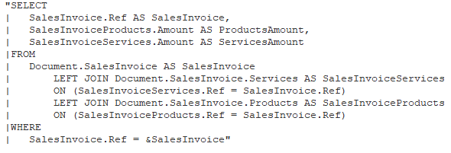
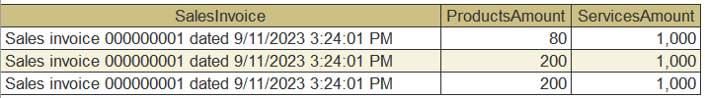
As a result, in each row of the result, the value of the amount of services is taken from the only row of the tabular part of the services - 1000. If we now group the rows by reference to the document, summing up the amounts of goods and services, then the amount of services will have a value of 3000, which is incorrect. So, it turns out that we first need to obtain the amounts of products and services for a given document, and then connect the data sources.
Let's rewrite the query using nested queries:
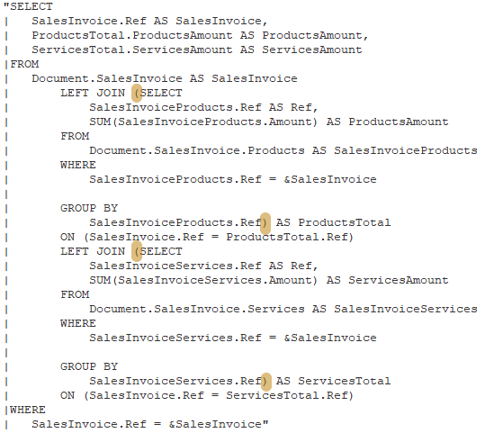

Here is how to add a nested query in Query wizard:
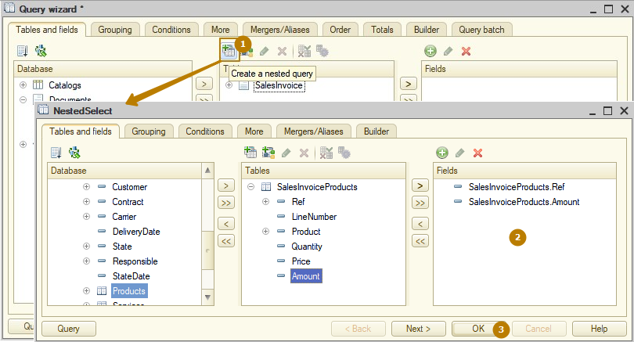
You can rename a nested query table. This improves query readability, especially if you have multiple nested queries:
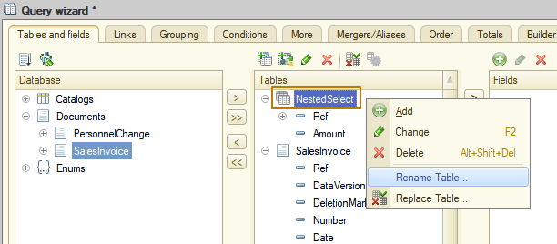
Merging queries
It is possible to merge several queries in the query language. In this case, the records obtained using each of the merged queries will be combined into one result of the query.
When merging, each query collects data independently, and such operations as ordering the results and calculating totals are performed on the query merging result already.
The fields of the query result will be named as described in the list of fields for selecting the first of the merged queries. The fields of the remaining queries selection are matched with the result fields in accordance with the order in which they appear in the list of selection fields. The merged queries must have the same number of fields in the list of selection fields.
This is the error the platform gives when trying to open the query wizard for a query with a different number of merged fields:
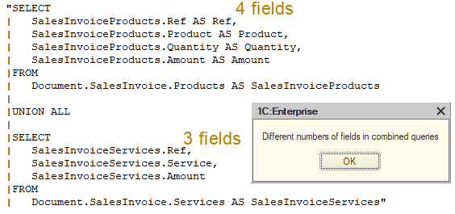
If the selection fields of the merged queries have different types, the query result fields will have a composite type.
To combine queries, use the UNION [ALL] keyword. UNION combines queries with the exclusion of identical records from different queries, this means that if you have absolutely matching records in all fields in the merged queries, then only the first of them will be taken. If the query result must include all records, regardless of whether they match or not, you should use UNION ALL.
Let's go back to the previous example of getting product and service amounts for documents. Let's use merging queries to select data from different tabular parts. Since the tabular part of products does not contain services, we will use 0 as the sum of services. Similarly for the tabular part of services - the sum of products will be 0.
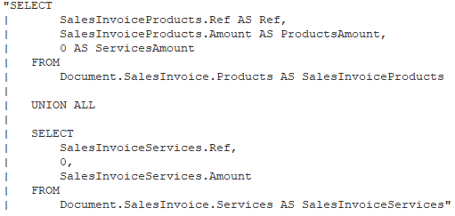
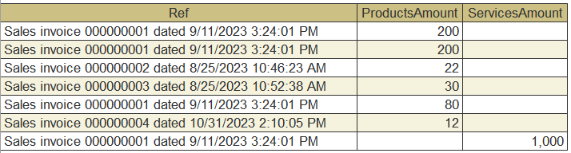
Please note that grouping is applied separately to each query from the union, so in order for these rows
Ref | ProductsAmount | ServicesAmount
Sales invoice 000000001 dated 9/11/2023 3:24:01 PM | 200
Sales invoice 000000001 dated 9/11/2023 3:24:01 PM | 200
Sales invoice 000000001 dated 9/11/2023 3:24:01 PM | 80
Sales invoice 000000001 dated 9/11/2023 3:24:01 PM |  | 1,000
were grouped into one line
Ref | ProductsAmount | ServicesAmount
Sales invoice 000000001 dated 9/11/2023 3:24:01 PM | 480 | 1,000
it is necessary to group the result of combining queries. To do this, you can place the selection in a nested query and group the data selected from this nested query:
"SELECT
| ProductsAndServices.Ref AS Ref,
| SUM(ProductsAndServices.ProductsAmount) AS ProductsAmount,
| SUM(ProductsAndServices.ServicesAmount) AS ServicesAmount
|FROM
| (SELECT
| SalesInvoiceProducts.Ref AS Ref,
| SalesInvoiceProducts.Amount AS ProductsAmount,
| 0 AS ServicesAmount
| FROM
| Document.SalesInvoice.Products AS SalesInvoiceProducts
|
| UNION ALL
|
| SELECT
| SalesInvoiceServices.Ref,
| 0,
| SalesInvoiceServices.Amount
| FROM
| Document.SalesInvoice.Services AS SalesInvoiceServices) AS ProductsAndServices
|
|GROUP BY
| ProductsAndServices.Ref"
The result of a query:
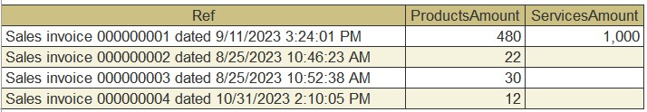
Calculating query totals
The TOTALS clause allows defining which totals must be calculated in the query. When calculating totals, aggregate function values are calculated by datasets with the same values of checkpoint fields. Totals are added to the query result as totals rows.
Description of the totals begins with the required TOTALS keyword. The list of aggregate functions contains aggregate functions (SUM, AVG, MIN, MAX, COUNT, COUNT (DISTINCT)) that must be calculated in the totals.
The OVERALL keyword means that it is required to generate a totals row for the entire query result.
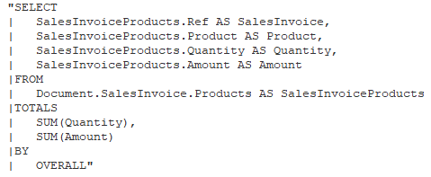
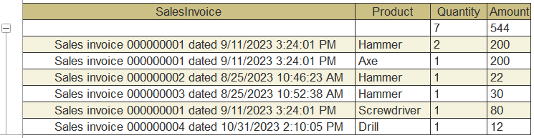
Besides grand totals, you can set the totals calculation by checkpoints. To do this, after the required BY keyword, specify groping fields as checkpoints. Each checkpoint contains an expression that is calculated when executing the query. For each combination of values of these expressions, the totals rows will be calculated and added to the query result.
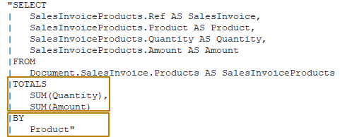
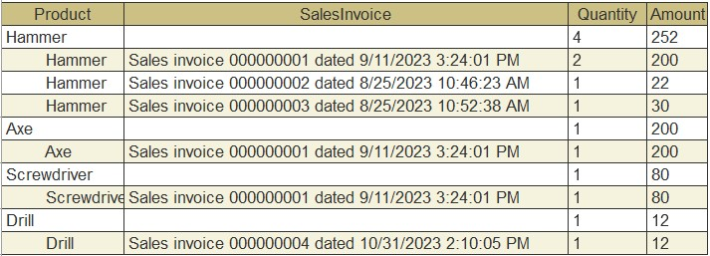
If a field of total grouping is a reference to a catalog, you can calculate totals by a catalog hierarchy. To do this, specify the required HIERARCHY keyword after such reference.
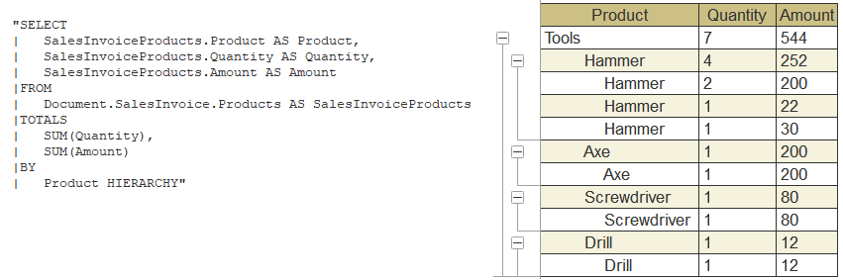
Expressions in query language
Built-in functions
There are built-in functions defined in the query language that can be used in expressions in the list of selection fields, filter conditions of table join and in the selection condition in the WHERE clause.
A list of built-in query language functions can be found in the custom expression window by clicking the button to add a new selection field or edit the selected selection field.
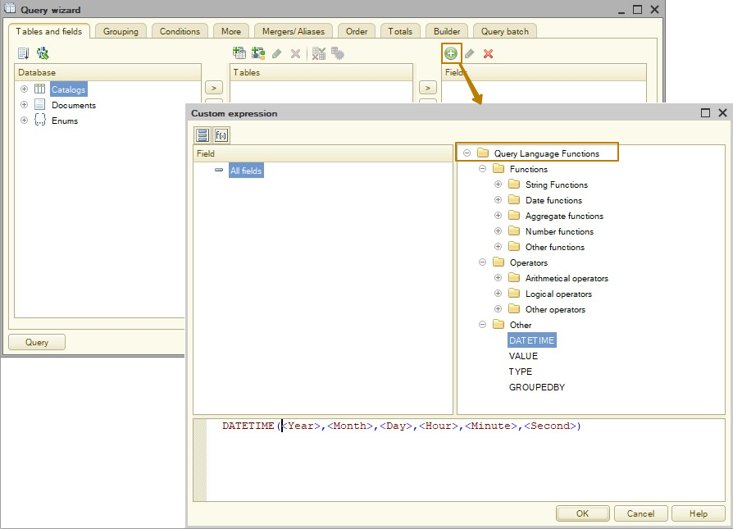
Information on how to use the built-in functions can be found in the help by searching for "Functions of query language":
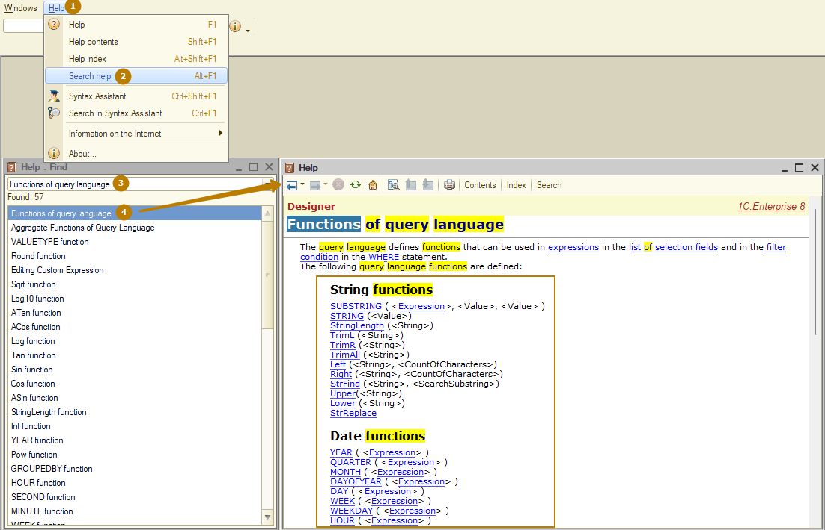
I won’t go into detail about all the built-in functions, I’ll just show you how to use a few of them, the rest you can learn on your own.
DATEDIFF(<Date1>, <Date2>, <Type>)
The function subtracts Date1 from Date2 and returns a number equal to the number of units specified in the Type parameter (SECOND, MINUTE, HOUR, DAY, MONTH, QUARTER, YEAR). In this case, it is the difference between the specified time units that is calculated without taking into account the remaining units.
DATEDIFF(Date1, Date2, Year), where Date1 = 31.12.2021 15:00:00 and Date2 = 01.01.2022 13:00:00
DATEDIFF(Date1, Date2, Year), where Date1 = 01.01.2021 14:00:00 and Date2 = 31.12.2022 18:00:00
For example, both expressions will return the value 1, because in both cases 2021 is subtracted from 2022, despite the fact that in the first case the difference between the dates is less than 1 full day, and in the second it’s almost 2 years.
VALUETYPE(<Expression>)
The function returns the type of value in the query.
Parameters: a function parameter is an expression of any type.
A return value is a Type value. If the function parameter is Undefined, the return value will also be Undefined.
For example, the Counterparties catalog contains the Contact attribute of a composite type: string and the CatalogRef.Contacts. Then the VALUETYPE() function will return the type of this attribute when we select data with a query.
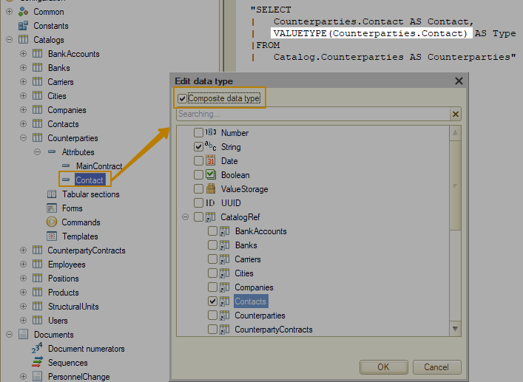
Selection operations
Query language expressions can use selection operations that allow one of the possible values to be retrieved in accordance with the specified conditions.
The selection operation is described by the following set of rules:
CASE
<Selection alternatives>
[ELSE <Expression>]
END
<Selection alternatives> can consist of any number of WHEN ... THEN select operation:
WHEN <Logical expression>
THEN <Expression>
These operations are processed sequentially in the query. If the logical expression is True, the selection operation processing is completed. The result of the operation is the value of the expression specified after the THEN word. The value of the expression specified after the ELSE word is used as the result of the selection operation, if the predicate was False in all the previously specified alternative single choices.
Example:
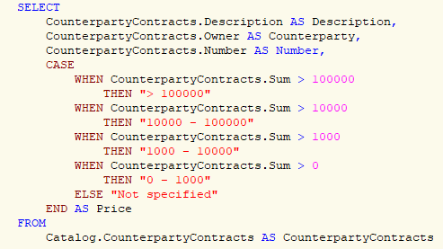
The result of a query:
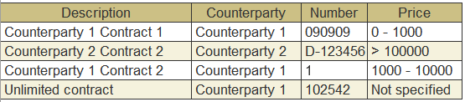

Type casting
Fields of source tables can be of composite type. For such fields, sometimes it is necessary to convert the field values to a specific type. The query language provides the feature to cast the type. It can be used in the list of selection fields and in the selection condition (in the WHERE clause).
CAST(<Expression> AS <Value type>)
The expression is cast to one of the primitive types or to the reference data type. In the second case, a table name refers to the respective infobase table.
If an expression contains a required type of value within a composite type, then the type casting is considered feasible, and for each value of the specified type, the result will be the same value. For values of other types, the result of the cast will be NULL.
If the expression does not contain the required type of value within the composite type, then the execution of this query will fail with an error due to the impossibility to perform a type casting.
Examples:
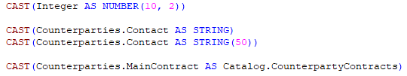
Constants and parameters
Query language expressions can directly indicate values of the Boolean, Number, String, or Date type. Query parameter values may also be used.
- TRUE
- FALSE
- <NUMBER type literal> (<Integer>[.<Integer>])
- <STRING type literal> (<Character sequence>)
- <DATE type literal> (DATETIME(<Integer>, <Integer>, <Integer>[, <Integer>, <Integer>, <Integer>])
- <TYPE type literal> (TYPE(<Type name>))
- <Parameter name> (&ParameterName)
- UNDEFINED
- NULL
Values of the Boolean, Number, String type in the query language are set in the same way as in 1C:Enterprise language.
Values of the Date type are specified using the DATETIME keyword, after which the year, month, day, hour, minute, second are successively indicated in round brackets. The last three values are optional.
Examples:
Number:
"SELECT
| 10 AS Integer,
| 12.45 AS Float"
String:
"SELECT
| ""123abc"" AS FirstString,
| ""abcdefghijklmnop"" AS SecondString"
Date:
"SELECT
| DATETIME(2023, 12, 31) AS NewYearEve,
| DATETIME(2024, 1, 1, 8, 30, 0) AS NewYearMorning"
Important! The maximum date that can be set using the DATETIME literal is 31.12.3999 23:59:59.
Parameters can be passed to the query. They also can be used in query language expressions. To do this, it is necessary to specify the "&" character followed by the parameter name.
Parameter:
"SELECT
| Products.Description AS Description,
| Products.Type AS Type,
| Products.Weight AS Weight
|FROM
| Catalog.Products AS Products
|WHERE
| Products.Ref = &Product"
<Type name> is a primitive type name or a name of the table whose reference type must be received. The result of this structure is the value of the Type type for the specified type. Type:
TYPE(String)
TYPE(Catalog.Products)

"SELECT
| Counterparties.Description AS Description,
| Counterparties.Contact AS Contact
|FROM
| Catalog.Counterparties AS Counterparties
|WHERE
| VALUETYPE(Counterparties.Contact) = TYPE(Catalog.Contacts)"
Conditions in query language
In the simplest case, the condition is an expression the result of which is a logical type value. Logical expressions are described in the next section.
Conditions can also be defined as more complex logical expressions, where simple logical expressions appear, connected to each other using the logical operators And, Or, Not. Logical operators have the following priorities:
- Not has the highest priority.
- And is the next in priority.
- Or has the lowest priority.
- In the conditions, simple logical expressions are calculated first, then Not operations, then And operations, and, finally, Or operations. Round brackets () can be used to ensure a different calculation order.
Logical expressions in query language
Logical expressions are used in the query language in selection operations and in filter conditions:
- <Expression>
- (<Expression> | <Logical expression>) <Comparison operation> (<Expression> | <Logical expression>)
- <Expression> [Not] IN [HIERARCHY] (<Value list>)
- <Expression> [Not] IN [HIERARCHY](<Query description>)
- <Expression> [Not] BETWEEN <Expression> AND <Expression>
- <Expression> IS [Not] NULL
- <Expression> REFS <Table name>
- <Expression> [Not] LIKE <STRING type literal> [Special character <STRING type literal>]
Comparison operations refer to mathematical comparison operations: >, <, =, >=, <=, <>

A logical expression can be:
- A regular expression of the query language if its result has a logical type.
- An operation of comparing two expressions of the query language. It is performed in accordance with the rules for comparing values described in the "Value comparison rules" section.
- An operator checking the match/mismatch of the expression value with one of the listed values or with the values contained in the result of another query.
- An operator checking whether the expression is included in the range.
- An operator checking an expression value for NULL.
- An operator checking a reference value of the expression for a reference to a specific table.
- An operator checking whether the string value matches the template.
When comparing values, the rules for comparing values described below are applied.
Value comparison rules
The rules for comparing values of different types in a query are used to perform the following actions:
- Compare values in comparison operators.
- Determine the maximum and minimum values in the MIN and MAX aggregate functions.
- Arrange query result records in accordance with the order specified in the ORDER BY clause.
If value types differ from each other, the relationship between the values is defined based on type priorities:
- NULL type (the lowest priority)
- Undefined type
- Boolean type
- Number type
- Date type
- String type
- Reference types
The relationship between different reference types is defined based on their internal table reference numbers corresponding to one type or another.
If the data types are identical, their values are compared according to the following rules:
- For the Boolean type, True is greater than False.
- For the Number type, general number comparison rules are applied.
- For the Date type, earlier dates are less than later dates.
- For the String type, the comparison is performed in accordance with the established national database characteristics and the specified sorting order. The comparison is case insensitive. The string comparison operation does not consider trailing spaces, unlike string comparison in 1C:Enterprise language where trailing spaces are included during the comparison operation. For example, comparing strings "bb" and "bb " in 1C:Enterprise language will return False (strings are not equal) and True in the query language (strings are equal). At the same time, it is not guaranteed that the sorting of the same data set performed on different DBMS will return the same result.
- Reference types and values with the UUID type are compared based on their values. At the same time, the repeatability of the comparison result is guaranteed only within one database.
- Comparing fields with the UUID type with fields of other types is not supported.
- It is not allowed to compare fields of unlimited length (strings of unlimited length, ValueStorage, the ValueType field from the table of the chart of characteristic types).
If the operation of comparing two values is used, where at least one NULL value is involved, NULL will be the result of the operation. If the result of a conditional expression (for example, in the WHERE, BY, WHEN clauses) is NULL, the condition is not satisfied.
Value matching operator
The "IN" operator to check whether the value matches one of the listed values
The IN operator allows you to check whether the value of the expression specified to the right from it matches one of the values described to the left. If at least one of them matches, the result of the operator will be True. Otherwise, False. Not changes the operator effect to the opposite one. Values are compared according to the rules described in the "Value comparison rules" section.
"SELECT
| SalesInvoice.Ref AS Ref
|FROM
| Document.SalesInvoice AS SalesInvoice
|WHERE
| SalesInvoice.State IN (VALUE(Enum.SalesInvoiceStates.InDelivery),
| VALUE(Enum.SalesInvoiceStates.Finished))"
For catalogs, the check can also be carried out for belonging to the hierarchy. The result of the IN HIERARCHY operator will be True if the value of the expression to the left is a reference to the catalog item and is included in the set of values to the right or hierarchically belongs to some group contained in this set.

"SELECT
| Products.Description
|FROM
| Catalog.Products AS Products
|WHERE
| Products.Ref IN HIERARCHY(&Group)"
The result of the query may also appear as a set of values for which a check is performed. In this case, it is necessary to specify a query description to the right from the IN operator.
Example:
"SELECT
| Products.Description
|FROM
| Catalog.Products AS Products
|WHERE
| Products.Ref IN HIERARCHY
| (SELECT
| Products.Ref
| FROM
| Catalog.Products AS Products
| WHERE
| Products.Description = ""Tools"")"
Using the "IN" operator to check if a value matches one of the query results:
// Select names of the products that were present in sales invoice documents
"SELECT
| Products.Description AS Description
|FROM
| Catalog.Products AS Products
|WHERE
| Products.Ref IN
| (SELECT
| SalesInvoiceProducts.Product
| FROM
| Document.SalesInvoice.Products AS SalesInvoiceProducts)"

The result:
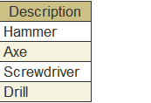
To retrieve the opposite result, that is, if it is necessary to determine that the value does not match any of the query results, the query will look as follows.
Example:
// Select names of the products that were present in sales invoices
"SELECT
| Products.Description AS Description
|FROM
| Catalog.Products AS Products
|WHERE
| NOT Products.Ref IN
| (SELECT
| SalesInvoiceProducts.Product
| FROM
| Document.SalesInvoice.Products AS SalesInvoiceProducts)"
The result:
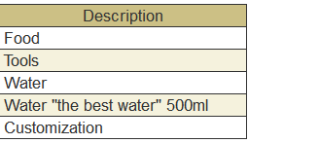
Using the "IN" ("Not IN") operation for multiple fields
Syntax for a nested query:
(expression1, expression2, …, expressionN) IN (SELECT expression1, expression2, …, expressionN FROM <DataSource>)
Example:
// Select PurchaseInvoice documents with company and vendor information, but only those in which the Company + Responsible coincides with the Company + Responsible of SalesInvoice documents

"SELECT
| PurchaseInvoice.Ref AS Ref,
| PurchaseInvoice.Company AS Company,
| PurchaseInvoice.Vendor AS Vendor
|FROM
| Document.PurchaseInvoice AS PurchaseInvoice
|WHERE
| (PurchaseInvoice.Company, PurchaseInvoice.Responsible) IN
| (SELECT
| SalesInvoice.Company,
| SalesInvoice.Responsible
| FROM
| Document.SalesInvoice AS SalesInvoice)"
The result:
Syntax for a value table:
(expression1, expression2, …, expressionN) IN (&Parameter)
As a parameter, pass a value table. Its first N columns will be used for the IN operation.
Syntax for building a list directly in a condition without a subquery:
(expression1) IN (“Some string”, 123, DATETIME(2023, 12, 31), True, VALUE(<MetadataClassName.MetadataObjectName.PredefinedValue>))
Example:
// Select sales documents in which the status is equal to one of several enumeration values
"SELECT
| SalesInvoice.Ref AS Ref,
| SalesInvoice.State AS State
|FROM
| Document.SalesInvoice AS SalesInvoice
|WHERE
| SalesInvoice.State IN (
| VALUE(Enum.SalesInvoiceStates.Planned),
| VALUE(Enum.SalesInvoiceStates.InDelivery)
| )"
The result:
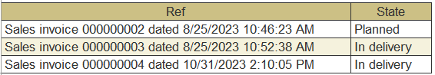
Operator checking if the value is in the range
The BETWEEN operator allows you to check whether the value of the expression specified to the left from it is in the range specified to the right. If it is included, the result of the operator will be True. Otherwise, False. NOT operator changes the operator effect to the opposite one.
Example:
"SELECT
| SalesInvoice.Ref AS SalesInvoice
|FROM
| Document.SalesInvoice AS SalesInvoice
|WHERE
| SalesInvoice.Date BETWEEN DATETIME(2023, 1, 1) AND &EndPeriod"
Operator checking the value for NULL
To check whether a value is NULL in a query you cannot use the "=" operator, because the logical expression “NULL = NULL” always returns False at query. The ISNULL operator allows you to check the value of the expression to the left for NULL. If the value is NULL, the result of the operator will be True. Otherwise, False. NOT changes the operator effect to the opposite one.
Example:
"SELECT
| NULL IS NULL AS CorrectChecking,
| NULL = NULL AS IncorrectChecking"
The result:
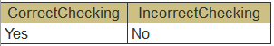
Since when using LEFT JOIN, a field from the right table can take the value NULL if no rows are found in the right table that satisfy the join condition, the IS NULL operator is used for tasks when you need to get rows from a mail table, provided that there are no suitable rows in the joined table. Let's look at an example to make it clearer. We want to select only those bank accounts that are not used in any counterparty contract.
To do this, we perform a JOIN, and then in the WHERE section we add a condition that the field from the right table has the value NULL (IS NULL):
"SELECT
| BankAccounts.Ref AS Ref,
| BankAccounts.Owner AS Owner
|FROM
| Catalog.BankAccounts AS BankAccounts
| LEFT JOIN Catalog.CounterpartyContracts AS CounterpartyContracts
| ON BankAccounts.Ref = CounterpartyContracts.BankAccount
|WHERE
| CounterpartyContracts.Ref IS NULL"
Operator checking reference values
The REFS operator allows you to check whether the value of the expression specified to the left from it is a reference to a table specified to the right. If yes, the result of the operator will be True. Otherwise, False.
Example:
"SELECT
| Counterparties.Description AS Description,
| Counterparties.Contact AS Contact
|FROM
| Catalog.Counterparties AS Counterparties
|WHERE
| Counterparties.Contact REFS Catalog.Contacts"
Operator checking if the string matches the template
The LIKE operator allows you to compare the value of the expression specified to its left with the template string specified to the right. The check is case-insensitive for characters in the string for any used DBMS. The value of the expression must be of the String type. If the expression value matches the template, the result of the operator will be True. Otherwise, False.
The following characters in the template string are service ones and have a meaning different from the string character:
- "%" (percent sign) stands for a sequence that contains any number of arbitrary characters.
- "_" (underscore) stands for a single arbitrary character.
- "[...]" (one or more characters in brackets) stands for any single character from the ones listed in brackets. A character set can contain ranges, such as a–z, meaning any character within the range, including the limits of the range.
- "[^...]" (a negation sign followed by one or more characters in brackets) stands for any character except for those listed after the negation sign.
Any other character represents itself only and does not have any additional meaning.
If it is necessary to write one of the listed characters as itself, then a special character must precede it. The special character itself (any suitable character) is defined in the same operator after the ESCAPE keyword.
For example, "A_[0-9][a-z]\_e%" is a substring that contains the following sequence of characters:
- Letters A or a
- Any character
- One digit
- One letter
- Underscore character
- Letters E or e
At the same time an arbitrary character set may be placed before this sequence.
When running the client/server mode, it is possible that the request containing the LIKE operator is not executed. This situation is possible if the length of the string with the template exceeds a certain number depending on the DBMS applied.
For example, let's try to find counterparties whose Contact attribute contains a string where:
- the first two characters are Mr or Ms
- then comes "."
- then an arbitrary set of characters is possible
- then the “#” sign
- then any number
- then an arbitrary set of characters is possible again
"SELECT
| Counterparties.Ref AS Ref,
| Counterparties.Contact AS Contact
|FROM
| Catalog.Counterparties AS Counterparties
|WHERE
| Counterparties.Contact LIKE ""M[rs][.]%[#][0-9]%"""
The result:
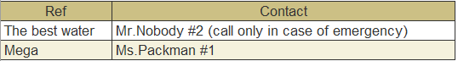
Query result iteration methods
Previously, we looked at ways to obtain data from the result of a query - data can be selected in one of two ways: the Select() method, which returns an object of the Selection type, and the Unload() method, which returns an object of the ValueTable type. Both methods have an optional TabOrderType parameter, which specifies the type of iteration of the query result. This parameter has three possible values: Linear, ByGroupsWithHierarchy and ByGroups. The default value is Linear.
If the query contains TOTALS, then its result is a tree; such data must be extracted from the query result indicating the QueryResultIteration.ByGroupsWithHierarchy iteration type in the Select() and Unload() methods. In this case, the Unload() method will return an object of the ValueTree type, and the Select() method will return a Selection in which the values can be iterated only at the first level. To iterate the values of subsequent levels, you need to execute the Select() method for each Selection to go one level “deeper”.
Let's go back to the example from the section Calculating query totals. We have one grouping field at Totals section: Product.
In order to iterate all records from such a query, you must first select data by grouping, then iterate this selection and at each iteration select a second-level selection from it:
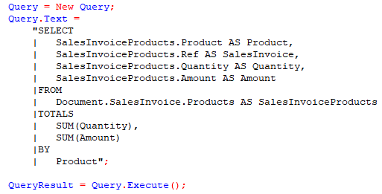
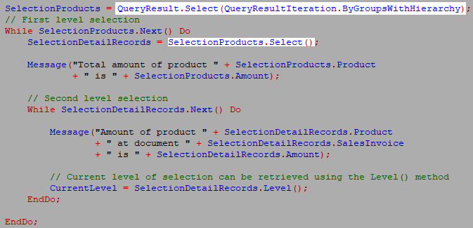
Selection from a query result has a Level() method that returns the current selection level, starting from 0.
Extracting data into a Value tree:
ValueTree = QueryResult.Unload(QueryResultIteration.ByGroupsWithHierarchy);
Managing temporary tables
1C:Enterprise query language allows you to use temporary tables in queries. Using temporary tables will improve query performance and simplify reading the query text.
Managing temporary tables is ensured by two components:
- The TempTablesManager object of 1C:Enterprise language that stores temporary table data.
- Query language syntax that allows creating new temporary tables and using the current ones.
A temporary table manager is intended to manage the existence time of temporary tables created during the application operations.
Each application supports creation of multiple instances of temporary tables manager, where each of them stores its own set of temporary tables. Within a single temporary table manager, each temporary table must have a unique name that is also a temporary table ID.
Note. Temporary table names must meet the requirements for names of 1C:Enterprise language variables.
Temporary tables manager instance may be created using the New constructor.
Example:
TempTablesManager = New TempTablesManager;
Each temporary table created in a given manager instance exists until this temporary tables manager instance exists. Deleting a temporary tables manager instance also deletes all the temporary tables contained in it.
The temporary table manager can be closed forcefully using the Close() method. All the tables created in it will be deleted. Further operating this temporary tables manager instance is not possible.
8.5.2.3. Creating temporary tables
Temporary tables are created using Query object of 1C:Enterprise language.
A query is linked to a temporary tables manager using the TempTablesManager property of the query, which specifies the manager instance where the temporary tables must be created.
Example:
Query = New Query;
- Creating a manager into a separate variable
TempTablesManager = New TempTablesManager;
Query.TempTablesManager = TempTablesManager;
- Creating a manager directly into the query property
Query.TempTablesManager = New TempTablesManager;
A temporary table can be created from database data or external data source (for example, a value table).
To create a temporary table based on database data, set a temporary table manager to the Query object and execute the database query using the INTO keyword followed by the name of the temporary table to be created. The INTO keyword must be specified after the query selection list.
Example:
"SELECT
| SalesInvoiceProducts.Product AS Product,
| SalesInvoiceProducts.Ref AS SalesInvoice
|INTO ProductsByDocuments
|FROM
| Document.SalesInvoice.Products AS SalesInvoiceProducts"
The values of the Product and SalesInvoice attributes for all the SalesInvoice documents will be placed in the temporary table. At the same time, in terms of 1C:Enterprise language, the result of such query will be the QueryResult object, the selection from which will contain one line with one column: Count. This number will indicate how many records were placed in the created temporary table.
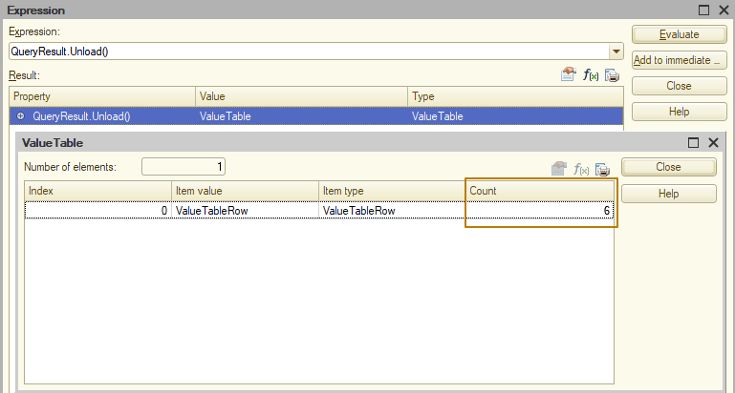
If the temporary table manager is not set or has been closed or a table with the specified name already exists in the set temporary table manager, an error will be displayed.
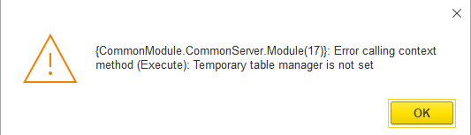
Use the RECORDAUTONUMBER() query language function to add a column to the created temporary table that will be filled with a unique number:
"SELECT
| SalesInvoiceProducts.Ref AS SalesInvoice,
| SalesInvoiceProducts.Product AS Product,
| RECORDAUTONUMBER() AS RecordNumber
|INTO TempTableProducts
|FROM
| Document.SalesInvoice.Products AS SalesInvoiceProducts"
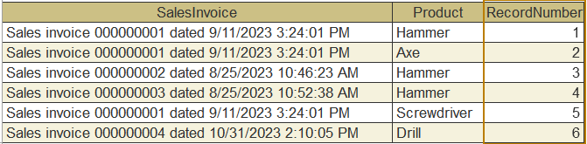
In order to create a temporary table based on an external source, the parameter name where the external source will be placed must be specified in the source list of the query text. Then create a temporary table as usual.
The following external data sources are available:
- Value table
- Tabular section
- Query result
An example of creating a temporary table based on the external data source is given below:
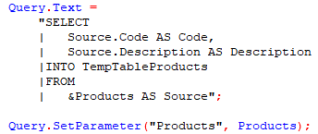
In this example, the contents of the Code and Description columns from an external source will be placed in the TempTableProducts temporary table. For example, the external source can be a Value table passed as the ExternalSource parameter. If the column value type is not specified in the value table that is used as the source for the temporary table, an error will be displayed. If a column without a specified type is used in any expression, for example in the CASE or ISNULL operations, an error will also be displayed.
Important. If a temporary table is created based on an external source, the query cannot use UNION and JOIN, as well as fields that are attributes of the table fields based on which the temporary table is created (for example, if a ref to a company is selected from an external source into a temporary table, you cannot select the Address attribute of the Companies catalog in the same query).
Using temporary tables
To use existing temporary tables, set a temporary table manager to the Query object in a TempTablesManager property. After that, you will be able to access temporary tables contained in this temporary table manager by name similar to regular query tables.
Example:
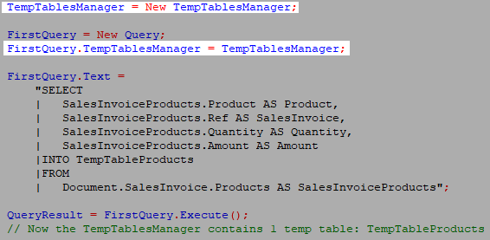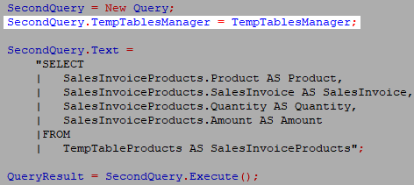
I created a temporary table in the temp tables manager at query 1, and then used this temp table at query 2, passing the same temp tables manager to it.
Dropping temporary tables
Since temporary tables require resources from the computer on which the DMBS is running (or on the current computer if the infobase type is file), you should create temporary tables with caution, especially if you know in advance that such tables will contain a lot of data (which means such tables will require a lot of resources). To avoid using unnecessary resources, temporary tables can be destroyed (dropped) when they are no longer needed. To drop a temporary table from the temporary table manager, use the DROP keyword of the query language followed by the name of the table being dropped, for example:
DROP TempTableProducts
If the table being dropped does not exist, an error will be generated.

How it looks at query wizard:
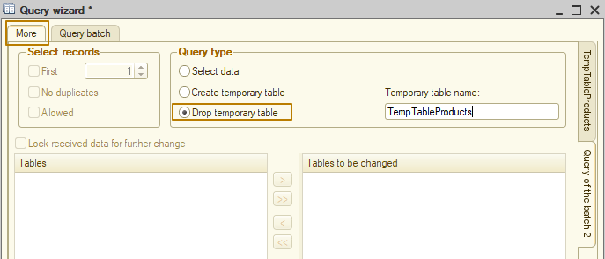
Debugging a query with temporary tables
When debugging complex queries containing temporary tables, it becomes necessary to analyze the content of temporary tables. This can be done in one of two ways:
- Using the ExecuteBatchWithIntermediateData() method of the Query object (Query.ExecuteBatchWithIntermediateData())
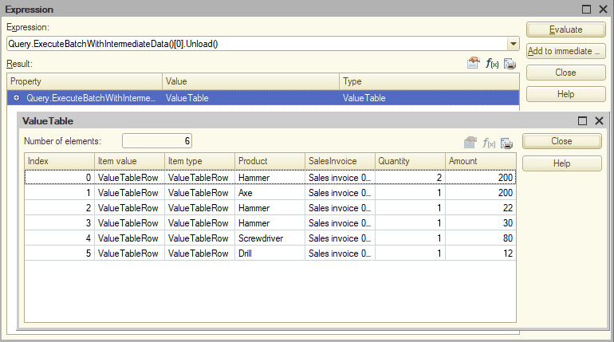
- By retrieving temp table data from the temporary table manager. After executing a query, the temporary table manager will store all added and undropped tables; they can be accessed by index or temporary table name. Calling the GetData() method will return the result of the request, and then data from the request result can be obtained as usual - using the Select() and Unload() methods
TempTablesManager = New TempTablesManager;

Query = New Query;
Query.TempTablesManager = TempTablesManager;

Query.Text =
"SELECT
| SalesInvoiceProducts.Product AS Product,
| SalesInvoiceProducts.Ref AS SalesInvoice,
| SalesInvoiceProducts.Quantity AS Quantity,
| SalesInvoiceProducts.Amount AS Amount
|INTO TempTableProducts
|FROM
| Document.SalesInvoice.Products AS SalesInvoiceProducts";

QueryResult = Query.Execute();

// Get data from temp table of temp tables manager and then unload the query result to a ValueTable
SalesInvoicesProducts = TempTablesManager.Tables["TempTableProducts"].GetData().Unload(); // Option 1
SalesInvoicesProducts = TempTablesManager.Tables[0].GetData().Unload(); // Option 2
As a result of the query execution, the TempTablesManager.Tables property will contain a collection of temporary tables added to the manager by a query.
Working with batch queries
1C:Enterprise platform allows you to use query batches. In a batch query, query texts are separated with a semicolon - ;. Queries are executed sequentially, while temporary tables that were created during the execution of a query will exist until the end of the execution of the entire query batch or until the operation in the batch query that destroys this temporary table.
Example:
Query = New Query;
Query.Text =
"SELECT
| PurchaseInvoiceProducts.Product AS Product,
| MAX(PurchaseInvoiceProducts.Price) AS PriceOfPurchase
|INTO TempTablePurchasedProducts
|FROM
| Document.PurchaseInvoice.Products AS PurchaseInvoiceProducts
|WHERE
| PurchaseInvoiceProducts.Ref.Posted
|
|GROUP BY
| PurchaseInvoiceProducts.Product
|;
|
|////////////////////////////////////////////////////////////////////////////////
|SELECT
| SalesInvoiceProducts.Product AS Product,
| MAX(SalesInvoiceProducts.Price) AS PriceOfSale
|INTO TempTableSoldProducts
|FROM
| Document.SalesInvoice.Products AS SalesInvoiceProducts
|WHERE
| SalesInvoiceProducts.Ref.Posted
|
|GROUP BY
| SalesInvoiceProducts.Product
|;
|
|////////////////////////////////////////////////////////////////////////////////
|SELECT
| TempTableSoldProducts.Product AS Product,
| TempTableSoldProducts.PriceOfSale AS PriceOfSale,
| TempTablePurchasedProducts.PriceOfPurchase AS PriceOfPurchase
|FROM
| TempTablePurchasedProducts AS TempTablePurchasedProducts
| INNER JOIN TempTableSoldProducts AS TempTableSoldProducts
| ON TempTablePurchasedProducts.Product = TempTableSoldProducts.Product";

QueryResult = Query.Execute();
The first two queries create temporary tables, the data from which is used in the third query.
If the Query object executing a batch query is set up with a temporary tables manager, temporary tables that have not been dropped as part of the batch query will be saved to the set manager. It is possible to use and drop temporary tables that existed in the set temporary tables manager at the time the batch was executed in the text of a batch query.
In addition to the Execute() method, which sequentially executes all the queries in the batch and returns the result of the last query of the batch, 1C:Enterprise platform provides another method, which is ExecuteBatch(). This method sequentially executes all the queries and returns an array of results for each query from the batch in the sequence of queries placed in the text of the batch. The result of the query for the dropping of a temporary table is the Undefined value , which is also placed in an array of results. Query batches are used to select multiple sets of data in one database call (these data sets may be unrelated to each other), that is, query batches are used not only for selecting data into temporary tables.
Example:
Query = New Query;
Query.Text =
"SELECT
| PurchaseInvoiceProducts.Product AS Product,
| SUM(PurchaseInvoiceProducts.Quantity) AS Quantity
|FROM
| Document.PurchaseInvoice.Products AS PurchaseInvoiceProducts
|WHERE
| PurchaseInvoiceProducts.Ref.Posted
|
|GROUP BY
| PurchaseInvoiceProducts.Product
|;
|
|////////////////////////////////////////////////////////////////////////////////
|SELECT
| SalesInvoiceProducts.Product AS Product,
| SUM(SalesInvoiceProducts.Quantity) AS Quantity
|FROM
| Document.SalesInvoice.Products AS SalesInvoiceProducts
|WHERE
| SalesInvoiceProducts.Ref.Posted
|
|GROUP BY
| SalesInvoiceProducts.Product";

QueryBatch = Query.ExecuteBatch(); // array with 2 query results
Purchases = QueryBatch[0].Select();
Sales = QueryBatch[1].Select();
An example of how to create a query batch using Query wizard:
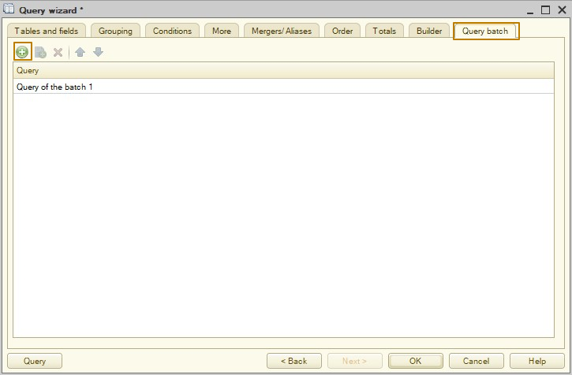
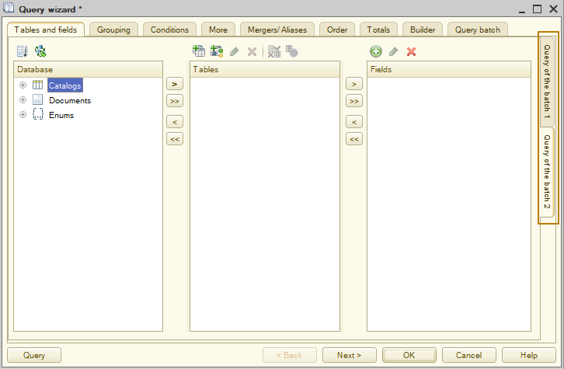
Queries that select data into a temporary table are represented by a temporary table name, queries that destroy a temporary table are represented by a minus symbol and a temporary table name (for example, “- Purchases”), regular queries are represented by Query Batch N, where N is the sequence number of the request in the batch, starting from 1.

